**DAY 6 TASK DATE:28.9.2023**

**a)write a constructor for the class movie, which takes a string representing the title of the movie, string representing the studio, a string representing the rating as its arguments and set the representive class properties to these value.**

**Ans:**

class movie{

constructor(title,studio,rating){

this.title=title;

this.studio=studio;

this.rating=rating;

}

}

var a=new movie("casino royale","eon production","PG13");

console.log("the rating is "+ a.rating);

**OUTPUT:**

the rating is PG13

**B)The constructor for the class movie, will set the class property rating to “PG” as default when no rating as provided.**

**ANS:**

**class movie{**

**constructor(title,studio,rating){**

**this.title=title;**

**this.studio=studio;**

**this.rating="PG";**

**}**

**}**

**var a=new movie("casino royale","eon production");**

**console.log(a.rating);**

**OUTPUT:**

**PG**

**C)write a method getPG, which takes an array of base type movie as its argument, and returns a New array of only those movie in the input array with a rating of “PG”. you may assume the input array is full of movie instances. The returned array need not to be full.**

**ANS:**

class movie{

constructor(title,studio,rating){

this.title=title;

this.studio=studio;

this.rating=rating;

}

get PG(){

return "the rating is "+a.rating;

}

}

var a=new movie("casino royale","eon production","PG");

console.log(a.PG);

**OUTPUT:**

the rating is PG

**d)write a piece of code that create a instances of the class movie with the title “ Casino Royale”, the studio “Eon Productions” and the rating “PG13”.**

**ANS:**

class movie{

constructor(title,studio,rating){

this.title=title;

this.studio=studio;

this.rating=rating;

}

}

var a=new movie("casino royale","eon production","PG");

console.log("the title is "+a.title+", the studio is "+a.studio+" and the rating is "+a.rating);

**OUTPUT:**

the title is casino royale, the studio is eon production and the rating is PG

**2**)

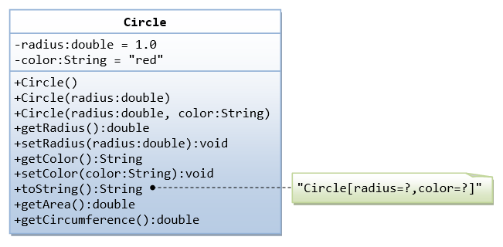

class circle{

constructor(radius,color){

this.radius=radius;

this.color=color;

}

getRadius()

{

return (`the radius is ${this.radius}`);

}

setRadius(radi)

{

this.radius=radi;

}

getColor()

{

return (`the color is ${this.color}`);

}

setColor(favoriteColor)

{

this.color=favoriteColor;

}

getArea()

{

return (`the area is ${Math.PI*this.radius*this.radius}`);

}

getCircumference()

{

return (`the Circumference is ${2*Math.PI*this.radius}`);

}

}

const circleValue = new circle(10,"blue");

console.log(circleValue. getRadius());

console.log(circleValue. getColor());

console.log(circleValue.getArea());

console.log(circleValue. getCircumference());

**OUTPUT:**

the radius is 10

the color is blue

the area is 314.1592653589793

the Circumference is 62.83185307179586

**3)Write a “person” class to hold all the details**

class Person{

constructor(name,DOB,age,emailID,qualification,city, state,country){

this.name=name;

this.DOB=DOB;

this.age=age;

this.emailID=emailID;

this.qualification=qualification;

this.city=city;

this.state=state;

this.country=country;

}

details(){

console.log(`

name:${this.name}

DOB:${this.DOB}

age:${this.age}

emailID:${this.emailID}

qualification:${this.qualification}

city:${this.city}

state:${this.state}

country:${this.country}`)

}

}

let Person1=new Person("NANDINI","2nd AUGUST","20","nandini.guvi@gmail.com","B.E","CHENNAI","TamilNadu","India")

Person1.details()

});

**OUTPUT:**

name:NANDINI

DOB:2nd AUGUST

age:20

emailID:nandini.guvi@gmail.com

qualification:B.E

city:CHENNAI

state:TamilNadu

country:India

**4) write a class to calculate uber price.**

class Uber_Price {

constructor(distance) {

this.distance = distance;

}

getPrice() {

return (this.distance ) *20;

}

}

let uber = new Uber_Price(10);

console.log(uber.getPrice());

});

**OUTPUT:** 200